

Contents

Scope 3

Functional Requirement 3

Non Functional Requirements 3

Technical Requirements 4

Stakeholders and Roles 4

List of pages 5

Home Page 5

About Us 6

Product 7

Contact Us 8

Register 9

Client Side JavaScript Validations 10

Login Validation 10

Register Page Validations 10

Conclusion 10

# Scope

The goal of this project is to create full functioning dynamic E-Commerce Website for The Xtream Sports NZ using the HTML5, CSS3, JavaScript, jQuery and PHP with zero cost.

# Functional Requirement

1. The user must login in order to buy products.
2. The user must register to the site in order to login.
3. The user must be able to search from anywhere on the website.
4. The user must add products to the Shopping cart.
5. The user must change the quantity of the product inside the shopping cart.
6. The Shopping cart must display the price correctly when customer update the product

Quantity.

1. The user must delete the certain product from the shopping cart.
2. The user must clear the full shopping cart.
3. The Registration Page should have client side validation and the Server side validation.
4. The Login must have client side and server side validation.
5. The user must give a feedback after buy some products.
6. The registered users must be able to change their login authentications.
7. The registered users must be able to change their billing address.
8. All users must be able to send inquiries to the admin team.
9. Admin access must be hidden to the public users.
10. Administrator must be able to customize the product in the website.
11. Administrator must be able to access to the user data.
12. User feedback must be able to see for all the users.
13. The User must be able to buy multiple products at a time.
14. The user must be able to see the login and register option in every page.

# Non Functional Requirements

1. The Website must be available to users 24/7 days.
2. The multiple users should be able to buy products without any crash in the website.
3. The Website should be able to secure the customer’s credit details.
4. The Website should be able to show some related products under each products.
5. The Website should have enough storage to process the businesses.
6. The Website should be able to respond to the users very fast.
7. The Website should be updated and maintained accordingly.
8. The Website should have a database backup storage.
9. The User must be able to delete their profiles from the website.
10. The Website should have a BACK TO TOP button to scroll the webpage up.

# Technical Requirements

|  |  |
| --- | --- |
| Software | Hardware |
| HTML5  CSS3  JavaScript  jQuery  Ajax  PHP  XAMPP Server-  Windows Version: Pro 64-bit  XAMPP Version: 7.0.13  Control Panel Version: 3.2.2 [ Compiled: Nov 12th 2015 ] | RAM-4 GB RAM  Processor-Intel Core i3 Processor CPU 2.10GHz  OS-Windows 10  System type- 64bit |

# Stakeholders and Roles

Client(Rohini)- Identifying the goal of the Website.

Building the requirements (Functional and Non-Functional) for the Website.

Programmer(Me)- Understand the requirement of the Business (Business Rules).

Designed the pages using HTML5 and external CSS3.

Use JavaScript and jQuery for client side validations.

Use php scripts to connect website with the server side database.

User- Performing the usability testing for the Website.

Web Admin- Add new products, delete products and update products in the website.

Fully controlling the Website content.

# List of pages

## Home Page

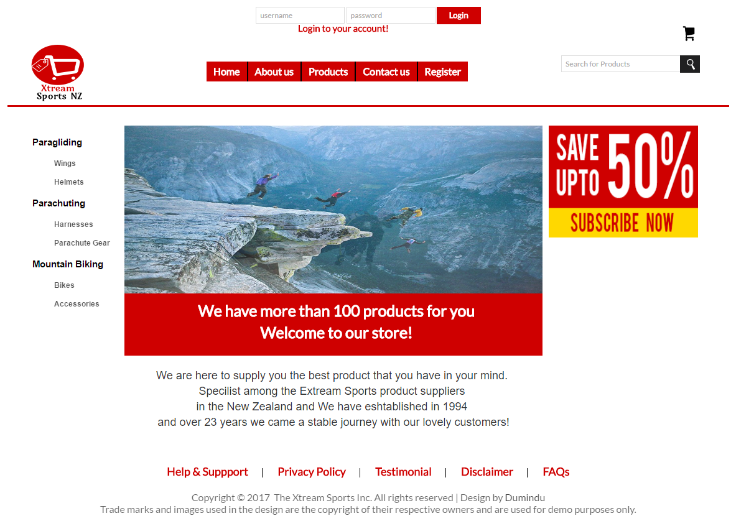

## About Us

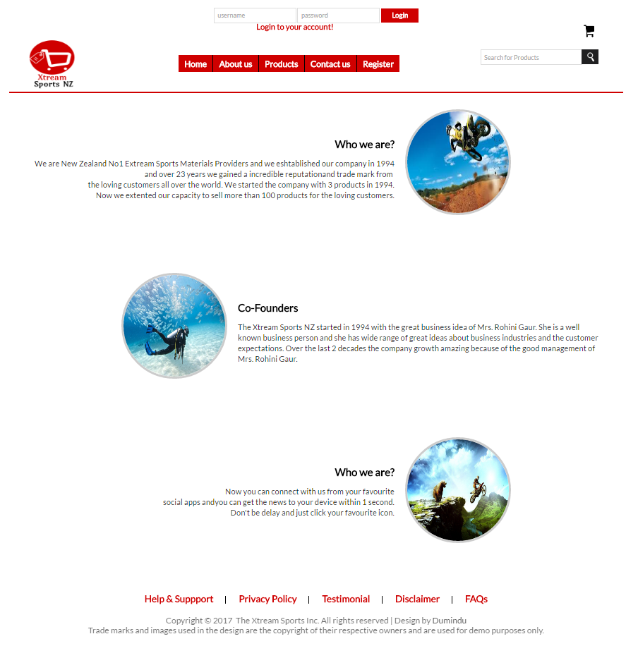

## Product



## Contact Us

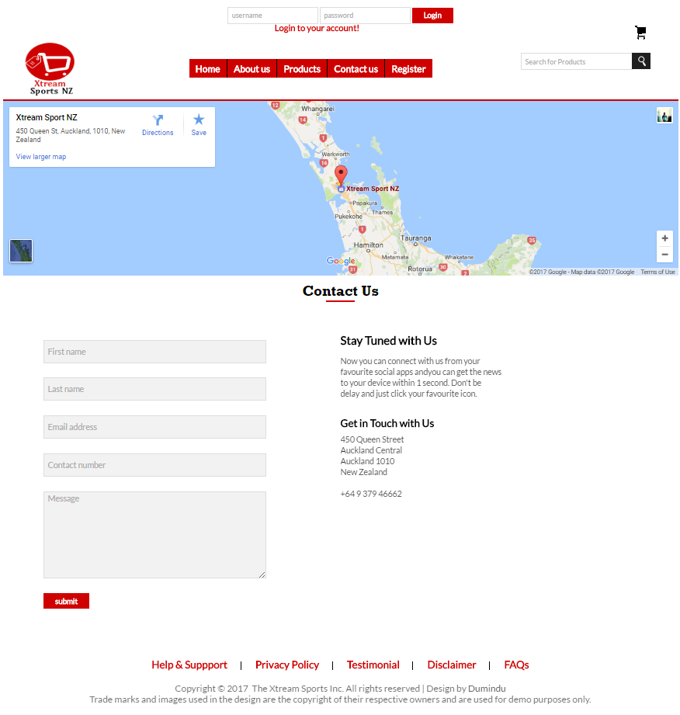

## Register

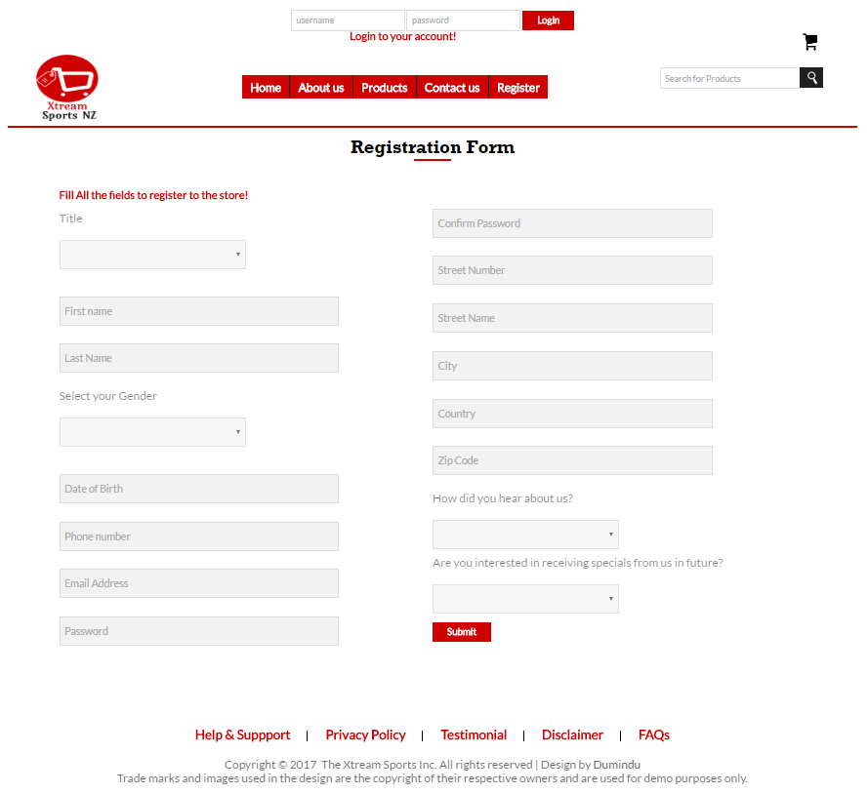

# Client Side JavaScript Validations

## Login Validation



## Register Page Validations

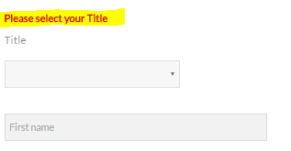

# Conclusion

The Purpose of this report is to understanding the structure of the Website and how to increase the development accordingly in future. The main focus in this milestone is to design appropriate pages that suit for the both customers and the owner. After front end phase is finalized the next thing is to work on backend development and create the dynamic E-Commerce website for the Xtream Sports.